# Project Design Phase-I Solution Architecture

|  |  |
| --- | --- |
| Date | 15 Oct 2022 |
| Team ID | PNT2022TMID04402 |
| Project Name | Global Sales Data Analytics |
| Maximum Marks | 4 Marks |

**Solution Architecture:**

Solution architecture for Global Sales Data Analytics consists of the following.

* Users need to authenticate through the device.
* Data to be gathered include sales data and customer data.
* Cleansing of data to delete void and duplicate data.
* IBM Cognos Analytics with Watson is IBM’s cloud analytics platform used.
* Data must be uploaded and then prepare data to connect data with relationships.
* With integrate with Cognos analytics our user Interface are deployed.

# Solution Architecture Diagram:

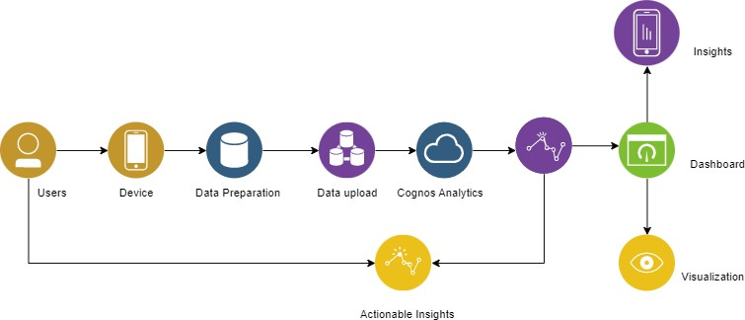

***Architecture and data flow of the Global Sales Data Analytics***